|  |
| --- |
|  |
| DBMS Lab Experiments |
|  |
|  |
| **Vansh Sukhija**  **12112021** |
|  |

|  |
| --- |
|  |

Experiment-2

TABLES-

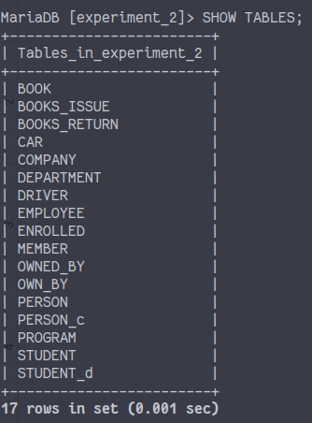

Data entered in some tables-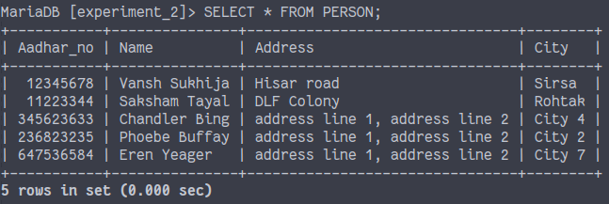

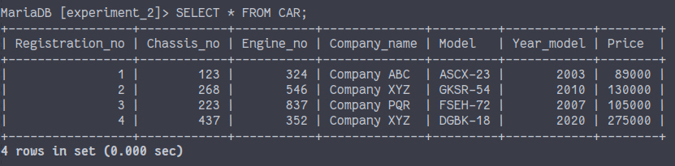

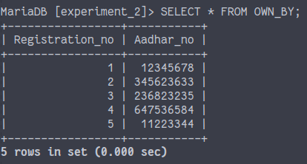

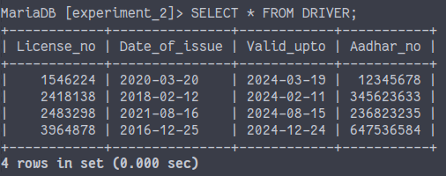

Experiment-3

(1). Update details of the guide of the student whose Roll-no is ‘110011’. The details of the

new guide are as Guide-name =‘Ram Mohan’ & Guide-No = ‘11’.



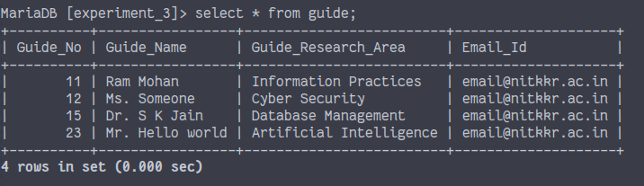

(2). Remove Guide details where Guide-No is ‘15’ and assign a new guide with Guide-No '10'

to all the students who were earlier assigned to the guide with Guide-No '15'.

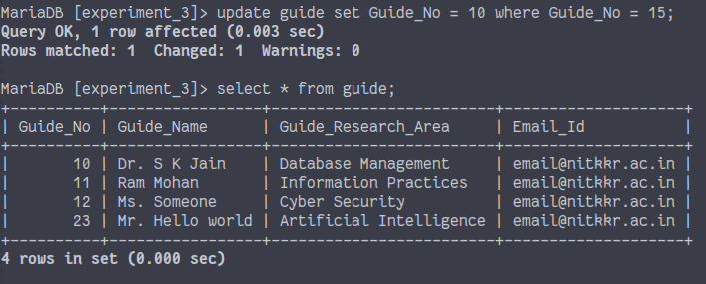

(3). Get a list of guides who are guiding more than two groups of students.

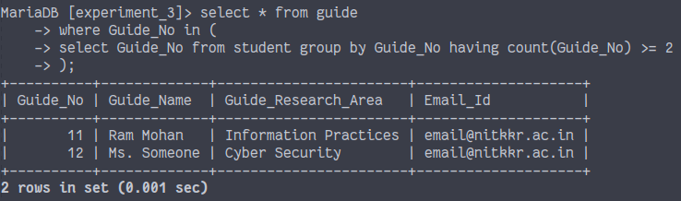

(4). Get a list of Project-No, Project-title, and names of guides who are guiding projects in the

Project area 'Database'.

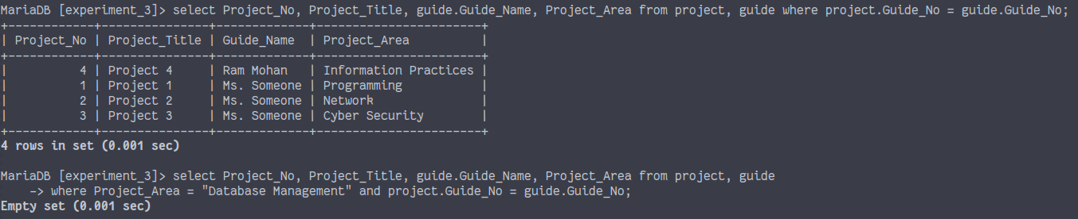

(5). Get title of the Project-No ‘5’.

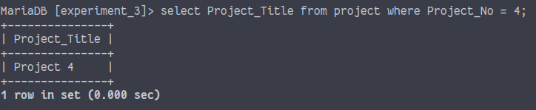

(6). Get names of all the students of the project no. ‘5’.

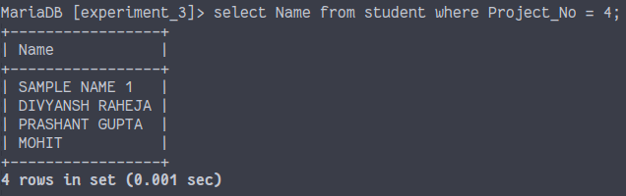

(7). List all the projects being guided by ‘Dr. S K Jain’.

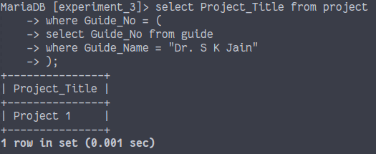

(8). Get names of all the students being guided by ‘Dr. S K Jain’.

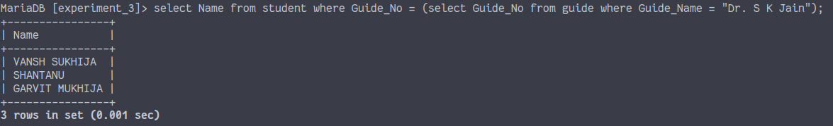

(9). List all the projects completed on ‘June 2019’.

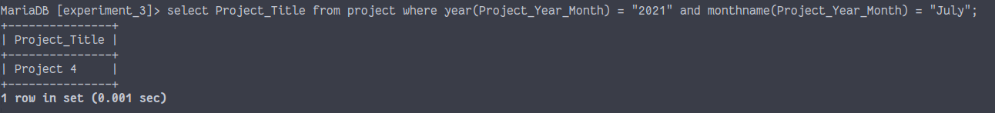

(10). List all the projects completed in year ‘2019’.

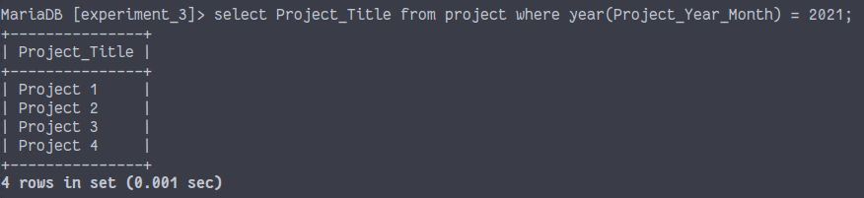

(11). Lists roll numbers and names of all the students who have their projects in Project area

“Programming”.

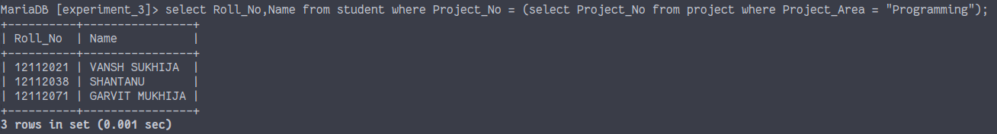

(12). List names of all the teachers who are guiding projects to the students in the Project area

“Network”.

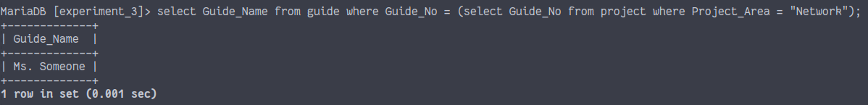

(13). List names of all the students who have their projects in the Project area “Artificial

Intelligence”.

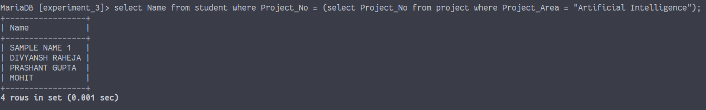

(14). List names of the guides with their Project areas.

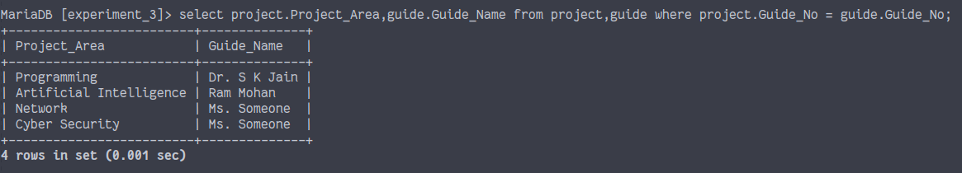

(16). List names of the students of the groups code ‘G3’.

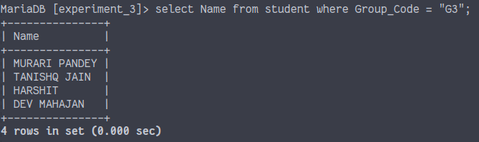

(18). Retrieve group-codes of the students whose guide is ‘Dr. S K Jain’.

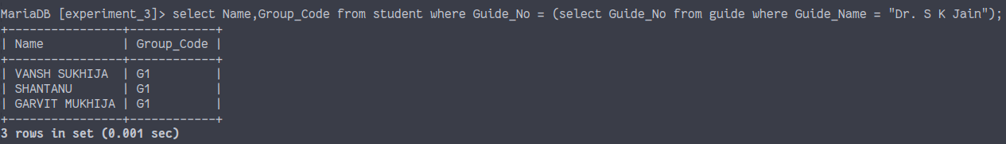

Experiment-4

BEFORE REMOVING FOREIGN KEY CONSTRAINT-

1. Cartesian product

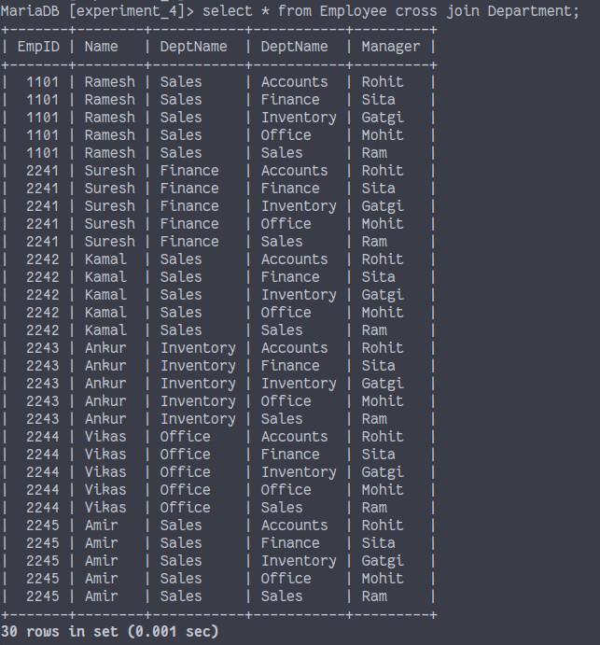

1. Natural join

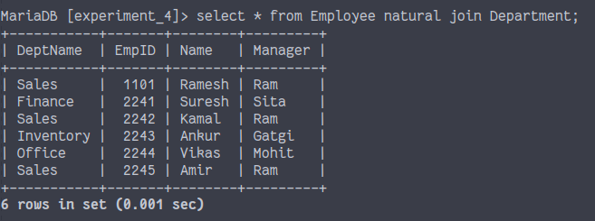

1. Left outer join

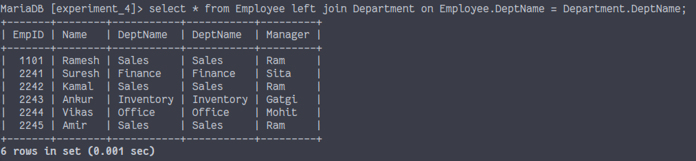

1. Right outer join

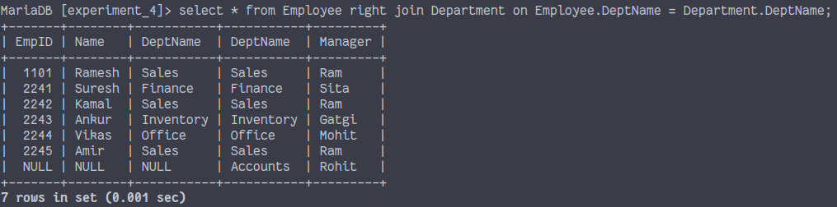

1. Full outer join

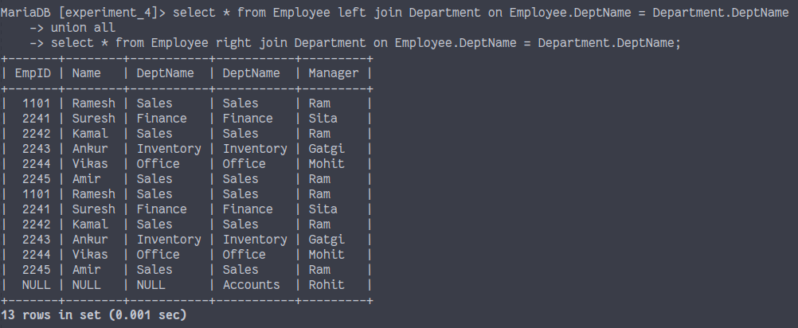

1. Left semi-join

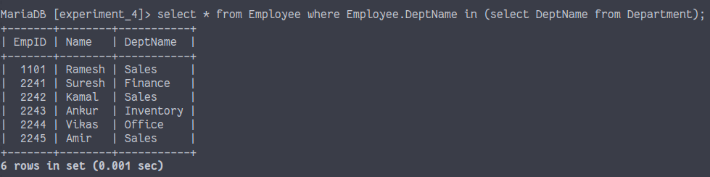

1. Right semi-join

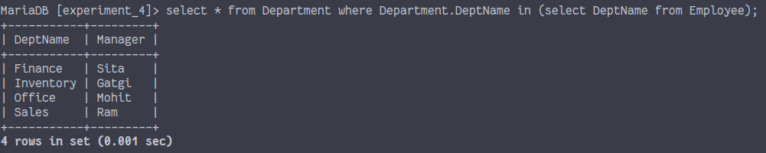

AFTER REMOVING FOREIGN KEY CONSTRAINT-

1. Cartesian product



1. Natural join



1. Left outer join



1. Right outer join



1. Full outer join



1. Left semi-join



1. Right semi-join



Experiment-5

(1). Increase Salary by 20 percent of all instructors who are working in Department IT.

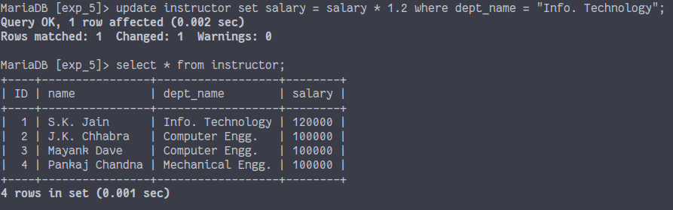

(2). Retrieve names of all instructors along with their department names.

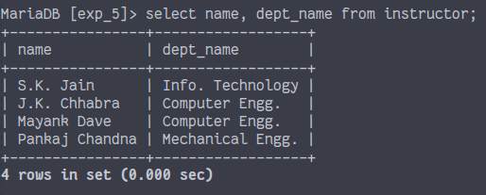

(3). Retrieve names of all instructors along with their department names and building names in which the departments are housed.

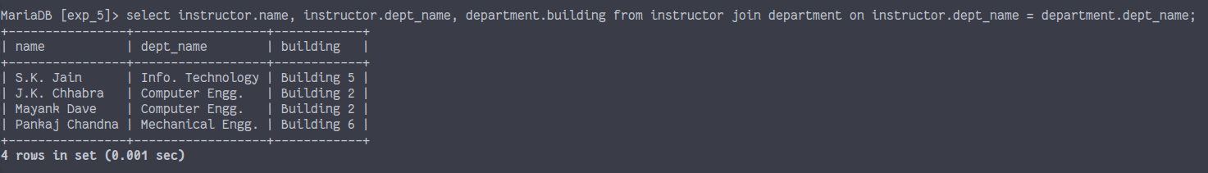

(4). Retrieve names of all departments along with names of the buildings in which they are situated.

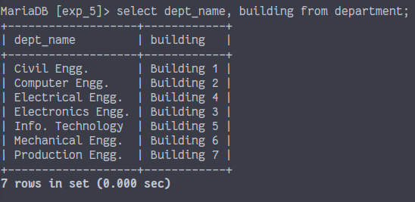

(5). Change name of the building "Lecture Hall Complex" to "Lecture Theatre Complex".

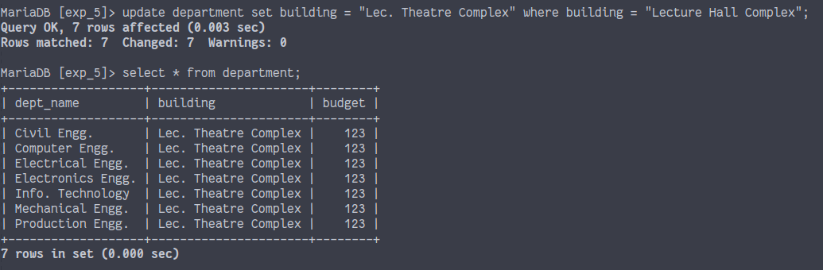

(6). Find name of the department of a student with ID _____. (Take a valid ID value of a

student)

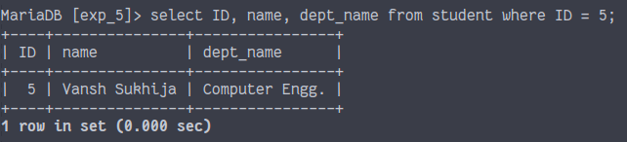

(7). Retrieve names of all instructors along with the Course IDs of the courses they teach.

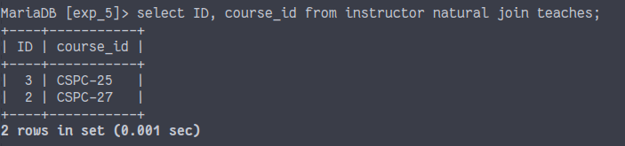

(8). Retrieve Course ID, semester, year and title of each course being taught by "Computer Engg." department.

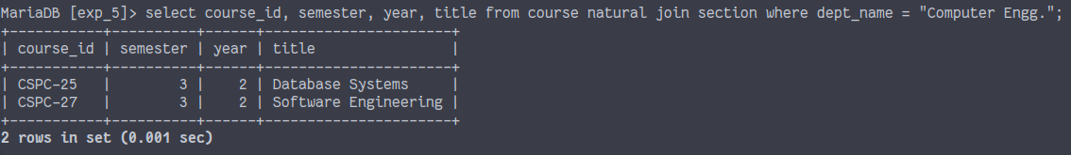

(9). Compute monthly salary of all instructors and display it as 'monthly salary' attribute in place of attribute 'salary'.

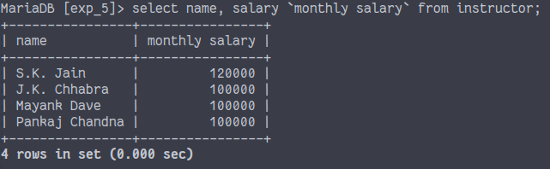

(10). Retrieve names of all departments housed in the building named _______. (Consider a valid Building name)

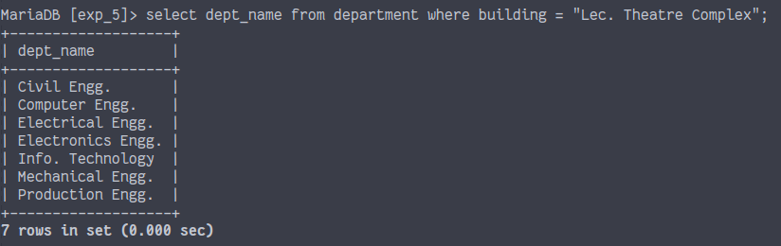

(11). Find the names of all instructors belonging to Computer Engg. department who have salary greater than Rs. 70,000.

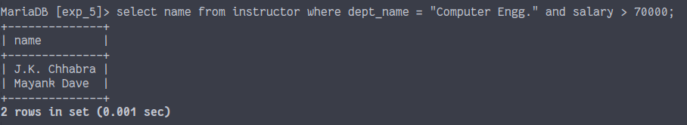

(12). Find titles of the courses that have credits 3 and offered by the department IT.

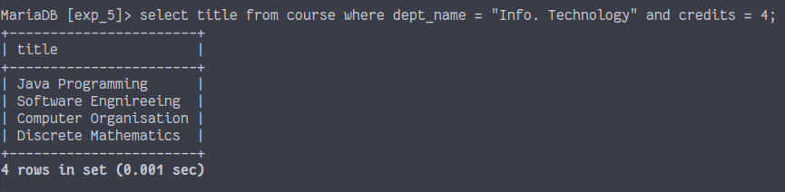

(13). Find course names and their credits running in semester 4.

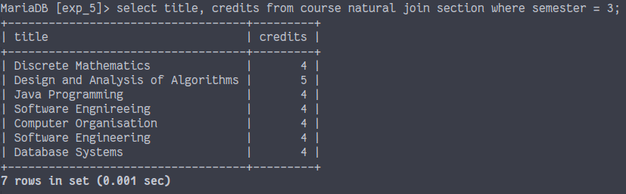

(14). List classes as year and semester wise engaged in room no. LHC-102.

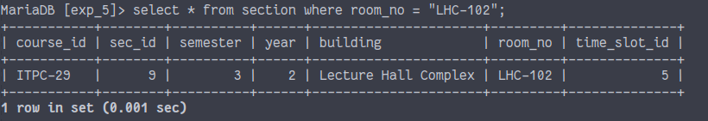

(15). List classes as year, semester and section wise engaged in room no. LHC-102.



(16). List classes as year, semester and section wise engaged in room no. LHC-101.

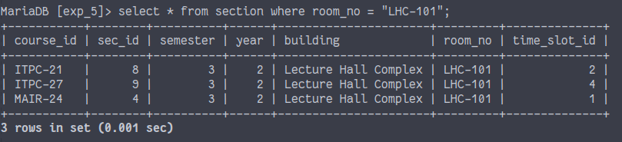

(17). Retrieve list of room number & time slot where all classes of Computer Engg.. Semester 7th are scheduled.

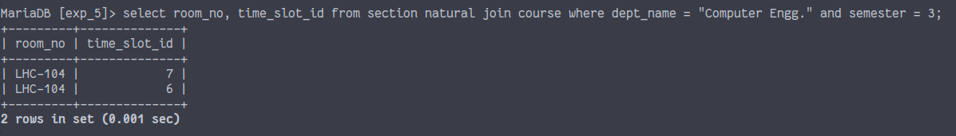

(18). Retrieve Course titles taught by instructor _______. (Take a valid instructor ID or name)

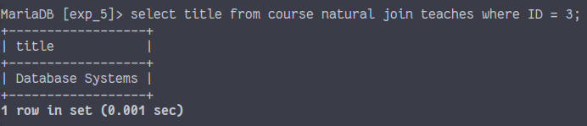

(19). For all instructors in the university who have taught some course, display their names along with their department names.

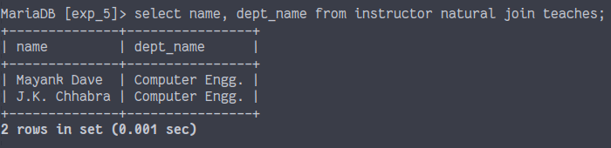

(20). Find the names of all instructors who have a higher salary than some instructor in

"Computer Engg." department.

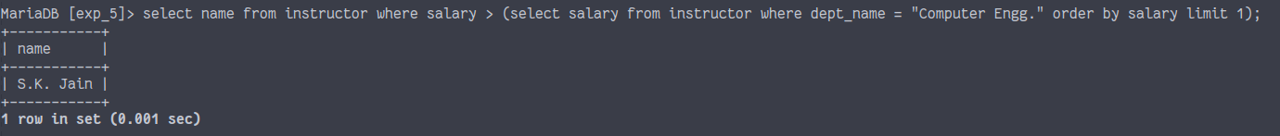

Experiment-6

(1). Find names of all departments whose building name includes the substring “Hall”.

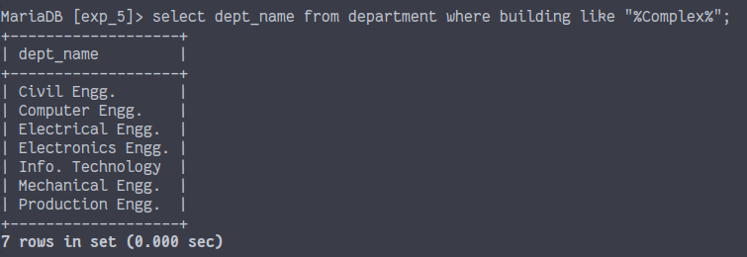

(2). Find names of all instructors who have their salaries between Rs. 50,000 and Rs. 80,000.

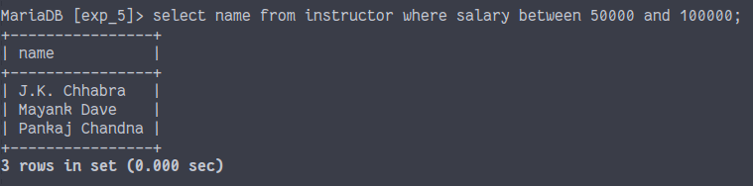

(3). Find names of all students whose names begin with string "Sa":

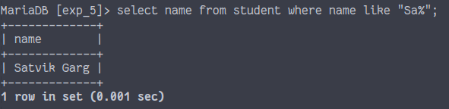

(4). Find names of all students belonging to Computer Engg. department and their names begin with character "Sa":

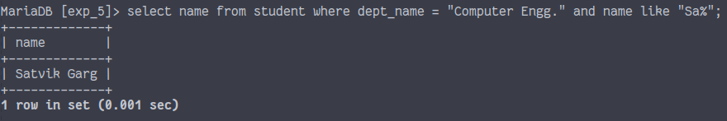

(5). Retrieve list of courses taught by teachers whose names begin with character "S".

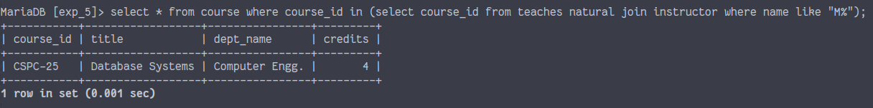

(6). Retrieve list of courses beginning their titles with word "Computer".

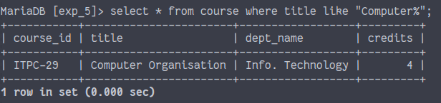

(7). Retrieve list of courses containing the word "language" in their titles.



(8). Retrieve names of the instructors who teach courses containing word "language" in their titles.



(9). Find IDs of all students whose names include "Kumari" and their department is IT.

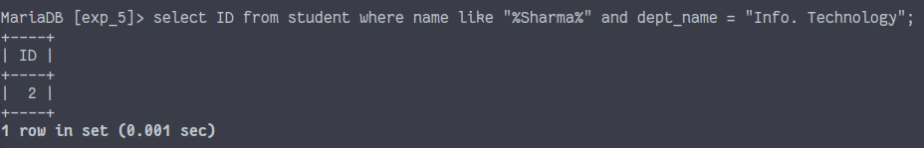

(10). Find average salary of all instructors.

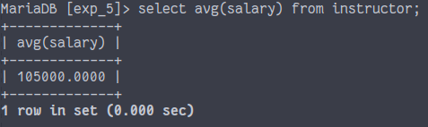

(11). Find average salary of the instructors belonging to Computer Engg, department.

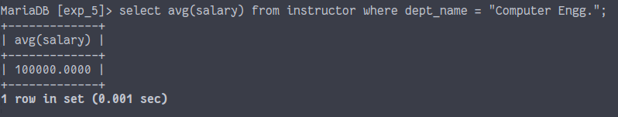

(12). Find average salary of the instructors belonging to each department.

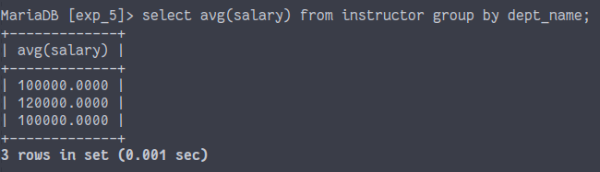

(13). Find names and average salaries of all departments whose average salary is greater than Rs. 60000.

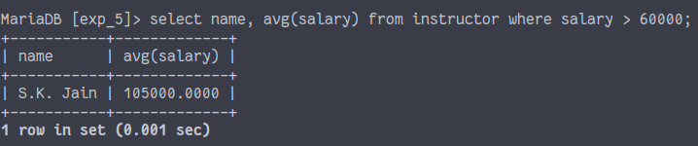

(14). Find total number of courses offered by the university.

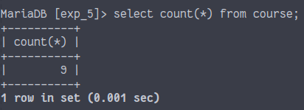

(15). Find total number of courses offered by the Computer Engg department.

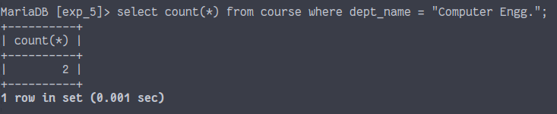

(18). Find maximum salary of an instructor belonging to Computer Engg, department.

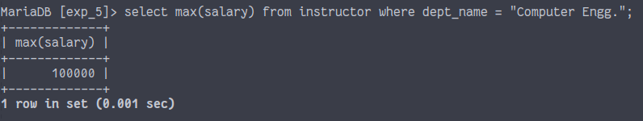

(19). Find minimum salary of an instructor belonging to Computer Engg, department.

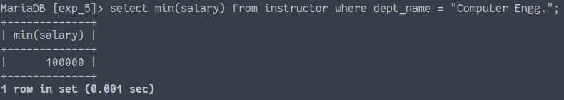

(20). Find maximum salary of an instructor in the university.

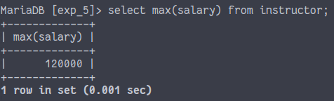

(21). Find total number of students enrolled in the university.

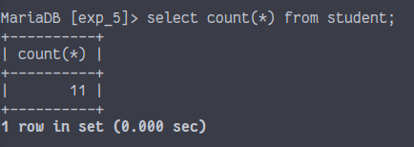

(22). Find total number of students enrolled in each department of the university.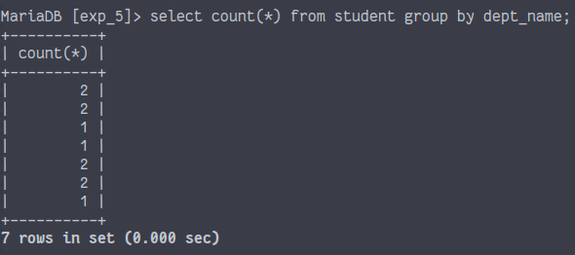

(23). Find instructors whose average salaries are greater than Rs. 42,000.

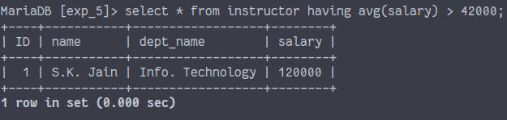

(25). Retrieve total no. of students in each department who earned total credits more than 8.

